Caring for country
Aboriginal stories tell us of Aboriginal people caring for Country. Country is their special place where they believe their ancestors have lived since the beginning of time. The scientific evidence shows that they have been on the continent at least 40,000 years.
By the eighteenth century, there were probably about 3,000 Eora (people)¹ living in the Sydney basin, from the Nepean/Hawkesbury river system to the coast. Families were small, but a number of families lived together in their own Ngurra (homeland) and shared the resources of the food and water. They also shared the responsibility of looking after the land and the water, according to the Law handed down from generation to generation through stories, songs, dance and artwork. This Law fostered harmony between all the elements of the ecosystem and maintained the natural biodiversity.
Within a few years of the European invasion of 1788, more than half the Eora had died from disease and other causes. However, families continued to live in the area. Today, Aboriginal people from other parts of Australia also live in the suburbs around the Cooks and Wolli Valleys.
We cannot be sure about the name of the clan (extended family group) that lived in our area, but some people believe they were the Bidjigal or Bediagal people of the Eora language group in the Dharug nation².
We use many of their words — such as Wolli, Turrella and Girrahween — even if we sometimes do not know what they mean.
Here are some possible meanings:
Girrahween – place of flowers
Turrella – reeds growing in water
Wolli – camping place
Minnamorra – plenty of fish.
Some people believe 'Bidjigal' means, 'men with spears country'³. The spears were from the flower spike of the grass trees (Xanthorrheas). The narrow, leathery leaves were used for weaving baskets and resin from the flower stalks was used as a glue for attaching hooks to fishing lines and stone arrowheads to spears.
'-gal' means country and the Cadigal were people who lived in the area south of Sydney Harbour while the Wangal were the people who lived north of the Cooks River. Hence the Eora north of the Cooks River were referred to as ‘Cadigal-Wangal’⁴.
We can walk the same paths that the Eora took through the valleys and along the waterways. We can see the caves where they sheltered from the rain and heat and we can see the kinds of trees and plants that they used for food and for medicine, for making spears and baskets and even rain cloaks.
Activity 1: Match the plants and animals listed below with their uses in the table that follows. To do this, you will need to think carefully. Hint: Look for the clues in the names and their uses!

The first one is done for you.

Wattle  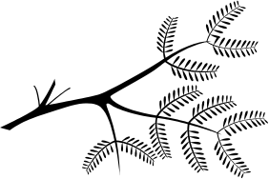 | Bangalay  Bark  Tree | Birds’  eggs  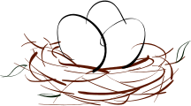 | Heath Banksia | 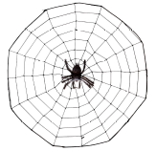Golden Orb Web
Honey 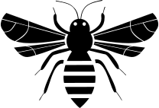 |   Fish | Paperbark  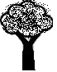 |   Bracken Fern | Lizards  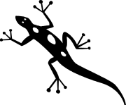
Wonga Vine  | Possums & Wallabies  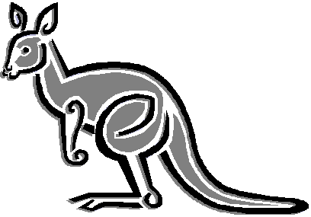 | Matt rush (Lomandra)  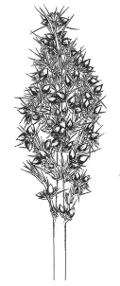 | Grass Tree  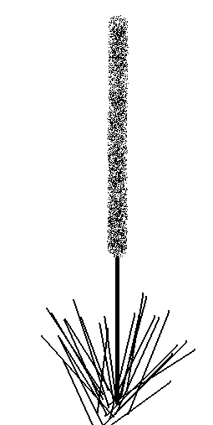 | Cabbage Tree Palm  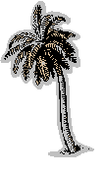
Mussels and    Oysters | Lilli pilli 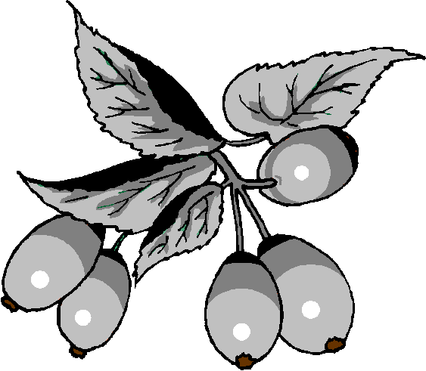

Name | How Used By The Eora
Honey | The small native bees (which do not sting) provided this sweet liquid in their hives.
 | The large palm leaves were sometimes draped over small branches to make summer shelters.
 | Sticky resin from the base made a great glue, the flower spike was stripped to make a spear and the tough grassy leaves could also be dried and woven into baskets
 | The thick, paper-like bark was sometimes used to patch canoes and the smooth inside layers were used as a soft blanket for newborn babies.
 | These were bony, and an important source of protein in the diet. The women paddled out in canoes and caught these on lines. Sometimes they were speared from the rocks by the men.
 | This plant has beautiful yellow flowers but it was the brown liquid (tannin) from the bark and leaves that could stun fish in waterholes causing them to float to the surface where they were easy to catch
 | The juice from the ferny leaves and stems stopped mosquito bites itching. The root was bitter but could be cooked and used as a vegetable.
 | The meat from these furry animals was roasted over an open fire then eaten
 | The small figs were food for lots of birds and grey-headed flying foxes.
 | A vine which was strong enough to be used for fishing lines and skipping ropes

Name | How Used By The Eora
 | Reptiles that could be speared or trapped then roasted over an open fire
 | Salty shellfish that were an important part of the Eora diet
 | These were easily collected from nests in trees and eaten raw.
 | The spiky seeds from these rushes were ground into a paste and roasted in the ground to make a kind of Pitta bread.
 | Whole sections of thick, dense bark were carefully removed from these trees to make waterproof canoes.
 | This tree grows sweet smooth purple berries that the Eora ate.
 | The brush-like flowers on this small tree drip nectar. The Cadigal knew when to collect the flowers to soak them in water to make a sweet, high-energy drink.
 | This fine silk, spidery thread was so strong it could be used for twine.

Activity 2: In the table above, use a red pen to circle the plants and animals we still use for food or medicine today.

Note: Very little specific information is known about the Indigenous occupation of the TVT area. These notes are based on general information gained from research.
1: Val Attenbrow, ‘Sydney’s Aboriginal Past, investigating the archaeological and historical records’, UNSW Press, 2002, p 17, p 35.
2: op cit, pp 24-25
3: Les Bursill, anthropologist, in conversation with Judi Rossi
4: ibid, pp 24-25

