amazing mangroves
Mangroves are amazing! They are plants that help keep our creeks and rivers healthy.

Did you know?
- Mangroves can live in salt water. The salt enters through the roots, travels through the plant to the older leaves then these die and drop back into the water.
- They have aerial roots that allow them to breathe even when the tide is high and their roots are under water
- Their rotting leaves are food for many marine animals and they form a rich mud that feeds bacteria, worms and small crustaceans such as crabs and prawns
- They are the beginning of a food chain that includes the crabs and prawns which are eaten by small fish - which are eaten by larger fish - which are eaten by birds such as pelicans
- Their seeds develop leaves while still on the tree and on some mangroves, the seedlings drop like arrows, planting themselves deeply into the mud underneath
- Their branches provide shelter and shade for small birds and spiders
- The nectar in the flowers is food for birds
- Larger birds such as cormorants, herons and egrets live among their branches
- The cool shallows under their branches are home to many baby fish.

For all these reasons, mangroves are amazing plants!
Activity 1: Use the words below to label the photos on the next page. Show parts of the mangrove and where the animals live.
Hint: write on the white space near each photo and connect your word to the parts using a line.

crab  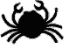 |  | mud  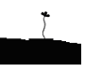 |  | leaves  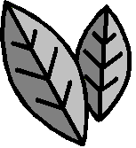 |  | trunk  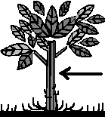
seedlings |  | spider |  | water |  | flower
 |  | 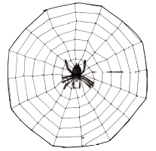 |  | 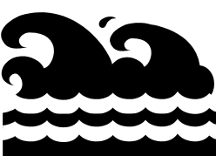 |  | 
canopy |  | small birds |  | worm |  | old leaves
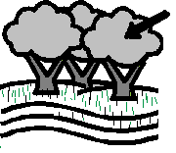 | 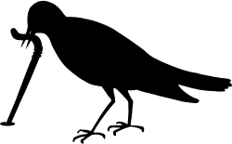 |  |  | 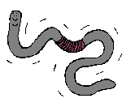 |  | 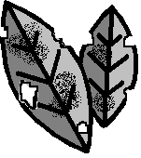
seeds |  | aerial roots |  | fish |  | branch
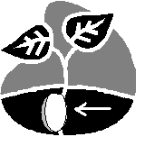 |  | 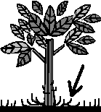 | 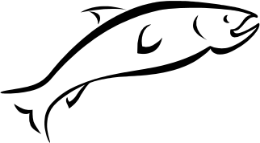 |  |  | 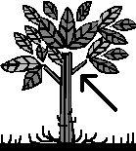

EG: flowers (on the ends of branches)

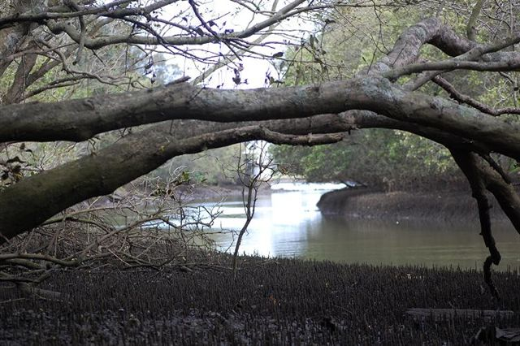
Photo of Cooks River mangroves by Voren O’Brien

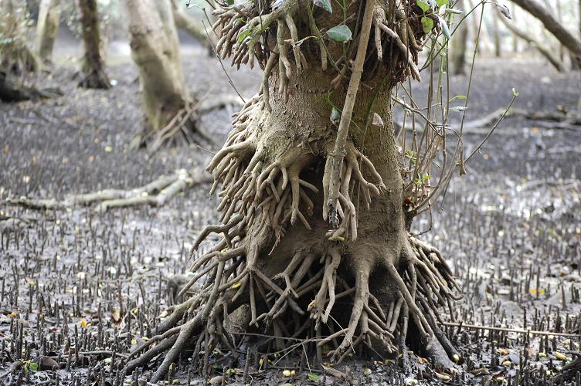
Photo of Wolli Creek mangrove by Voren O’Brien
Activity 2: Study the diagram below then complete the tasks that follow.

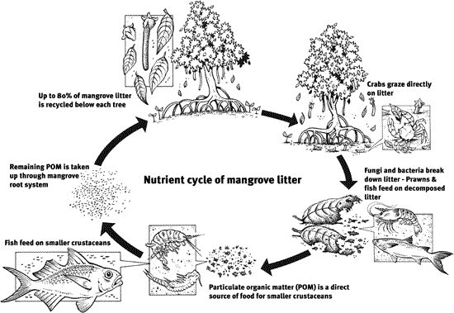

‘Why We Need Mangroves’, Department of Primary Industries and Fisheries, Queensland
http://www2.dpi.qld.gov.au/fishweb/2618.html, viewed 25 Feb 2008

In the diagram below, add words between the arrows to show who eats who.

Select from these words:

large  fish | seals | baby  fish | oysters | crabs and prawns

rotting
mangrove pelicans
leaves eaten by eaten by eaten by eaten by

Congratulations! You’ve just completed a Food Chain.
Activity 3: Draw a mangrove leaf.

Activity 4: Why might it taste salty on one side?

Activity 5: How does the mangrove spread?

Activity 6: Not all seeds grow into trees. Why not?

Activity 7: How can we help look after our amazing mangroves?

