living things - checklist
PLANTS
Here’s a short list of plants that grow in this area. You can work in groups to tick them off the list as you see them. Are they native or introduced species? Your teacher will help you identify them!
Note: the words in italics are Latin names for the plants.

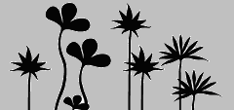 Groundcovers | Shrubs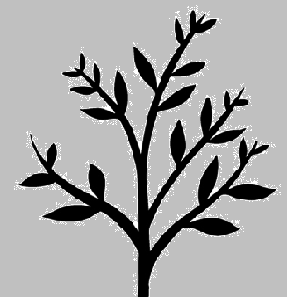 | Trees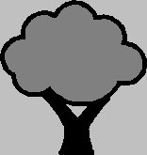
Matt Rush (Lomandra) | Banksia | Paperbark
Bracken Fern | Wattle (Acacia) | Mangrove
King Fern | Bottlebrush | She-oak (Casuarina)
Kikuyu Grass | Grass Tree (Xanthorrhoea) | Banksia
Buffalo Grass | Privet | Apple Gum (Angophora)
Madeira Vine | Lantana | Turpentine
Wonga Wonga Vine | Blackberry | Cabbage Tree Palm
Balloon Vine | Prickly Pear | Mulberry tree
Morning Glory | Mistletoe | Willow tree
Saltmarsh |  | Coral Tree
Reeds
Use the empty lines to add the names of other plants or fungi that you find along the way.
ANIMALS
Here are some birds and animals you might see.
Are they native or introduced species? Your guide can tell you which ones are native. Tick when you see them.

Insects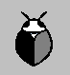 | Birds 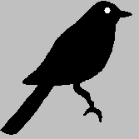 | Water birds 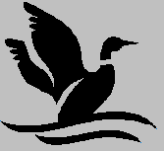
bee | crow | duck
beetle | kookaburra | egret
bug | lorikeet | heron
butterfly | magpie | ibis
cicada | noisy miners | moorhen
dragonfly | pigeon | pelican
fly | sparrow | seagull
moth | wren
wasp
Spiders 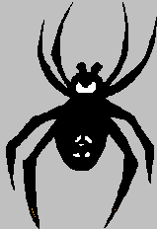 | Reptiles 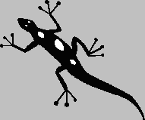 | Waterlife 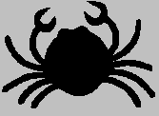
garden orb weaver | blue tongue | crab
golden orb weaver | skink | fish
leaf curler | snake | frog
 | turtle | tadpole
 | water dragon
Use the empty lines to add other creatures that you find along the way.

